# BIOCAT User Guide Nov 2012

The main screen in BIOCAT allows the user to select three tasks:

1. Model Selection for creating classification/annotation model
2. Training only without testing to create the model
3. Annotation

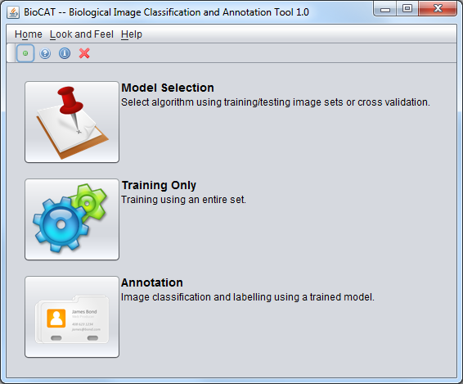

BIOCAT Main Screen

## Model Selection

Model selection allows the user to select whether to use different training and testing data sets (Training/Testing mode) or a single data set for both training and testing (Cross-validation mode).

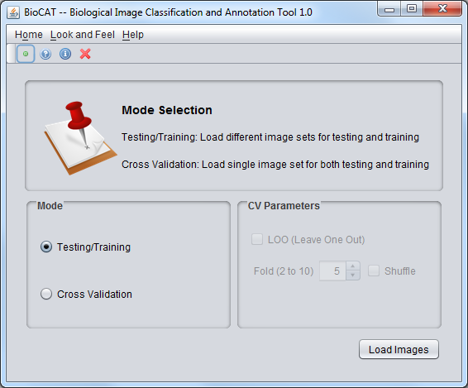

Model Selection Screen

The cross validation mode allows the following options:

1. LOO (Leave One Out): Leave one image for testing
2. Fold (2 to 10): Divide image set into specified number of sets. One of the sets will be used for testing
3. Shuffle: Shuffle the images. Useful for cross-validation if the images in the set are ordered based on category.

Once the "load images" button is clicked, the application will display the interface for loading the image set(s). In this screen, the user will select the image folder as well as the target text file.

## Loading Image Sets

## 

There are several modes of data input. Target File will ask for the folder containing all of the images as well as the target file. Directory Tree requires a parent directory containing appropriately named subfolders of the image sets. ROI (Region of Interest) mode will need ROI files (zip files from ImageJ) and the image file associated with those ROIs.

## Single Mode and Multiple mode

Once the training and testing images (or single set for both) are loaded, the user can choose to use either the simple mode or the auto comparison mode. First, the user needs to select the target color channel and then use either "Single" or "Multiple" button to load the respective modes.

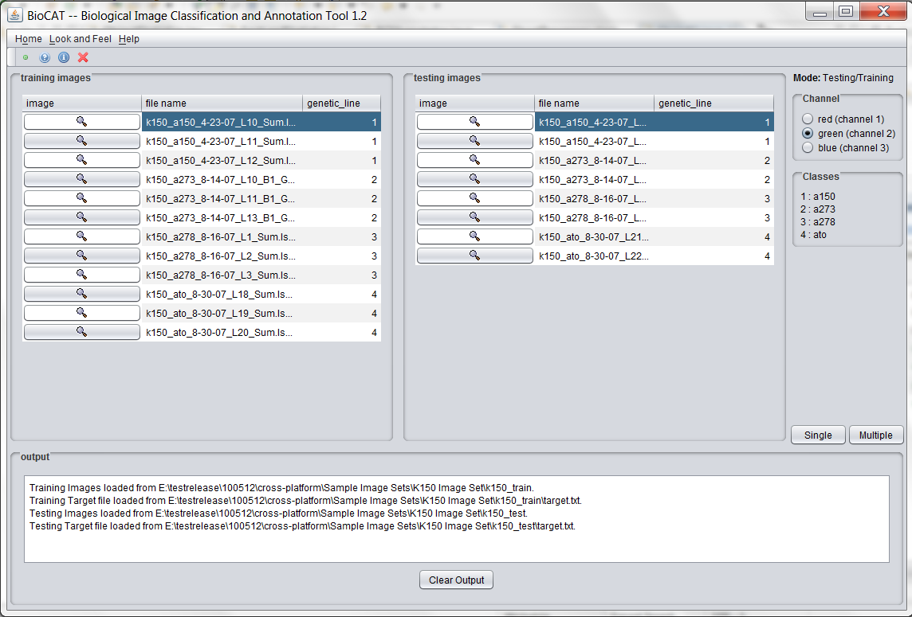

Loaded Images in Training/Testing Mode

Single Mode

In this mode, one feature extractor, one feature selector and one classifier can be selected using the drop down lists. Appropriate parameters can be supplied after selecting an algorithm. Once the desired algorithms and parameters are provided, the user can click on the "run" button to start the process. When the process completes the results will be displayed and the buttons to save the model and to annotate another image set will be enabled.

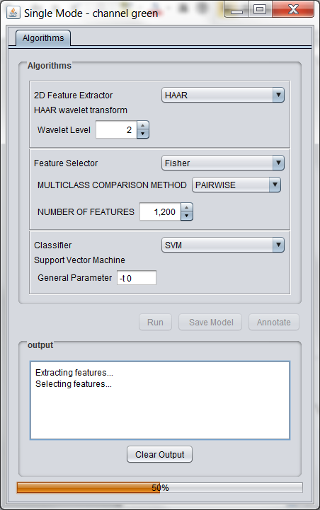

Simple Mode Screen

Multiple Mode for Comparison

In the Multiple mode (called Auto Comparison mode in early versions), the user can create a list of algorithm chains (extractor(s) - selector(s) - classifier), select the desired chains and hit the "run" button to find the comparison result for the chains. The best chain detected will be available for saving and for use in another annotation.

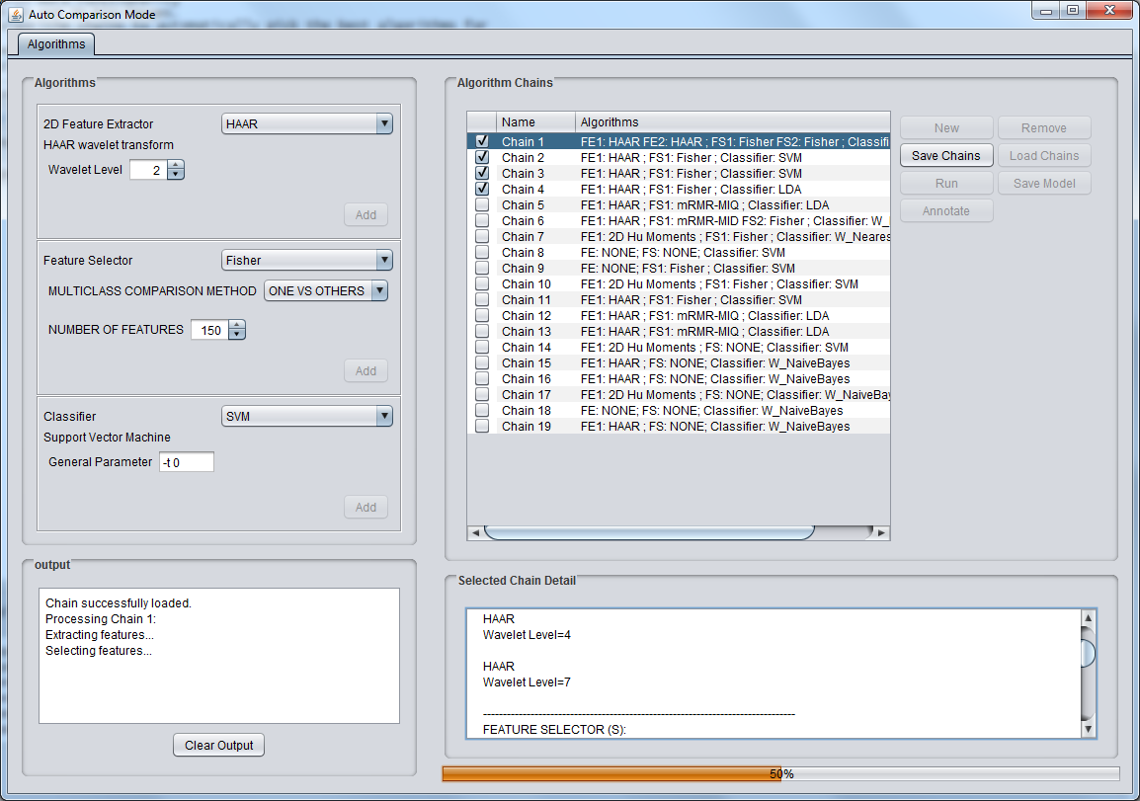

**Multiple Mode Screen**

## Annotation

There are two classification/annotation modes available. Image Classification/Annotation, which works on entire image, and ROI (Region of Interest) Annotation, which annotates regions within an image.

Both these modes can be used by loading a saved model from hard drive or by using the previously trained image. In the latter case, the process is initiated from either the simple mode or comparison mode windows.

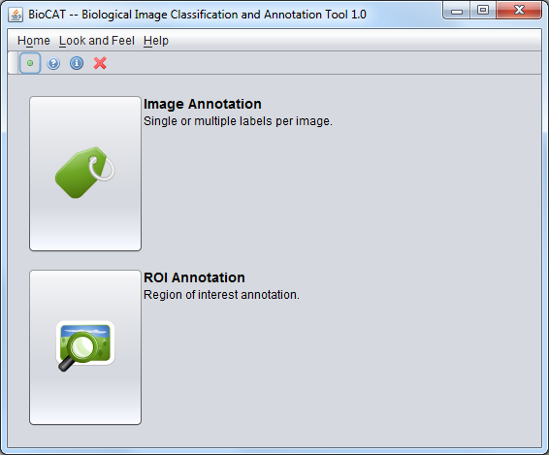

Annotation Modes

### Image Classification/Annotation

In this mode, once the target image set is loaded, the "apply model" button will be enabled if there is already a trained model available from previous operation. Otherwise, the user needs to load the model file from the hard drive. Once, the model is loaded, it can be applied to the target image set.

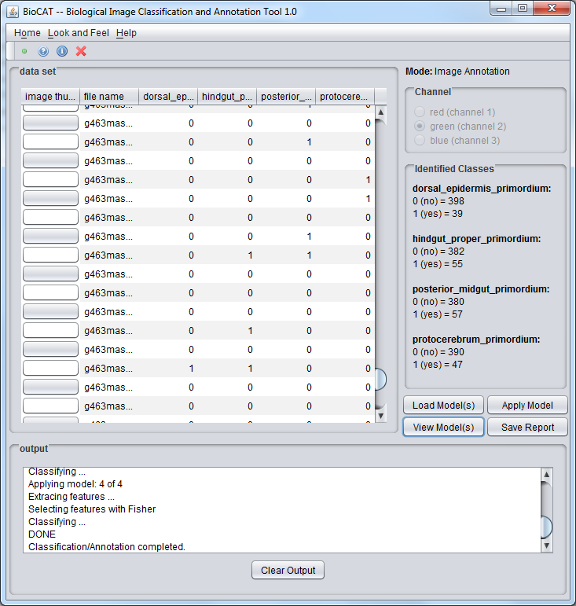

Annotation Result for binary annotation target

### ROI Annotation

This mode allows the user to pick the interval size for moving the region of interest over the target image. The size of the images used for training the model will be the size for the region of interest. One or more images have to be selected from the list before applying the model. The result annotation will be overlaid on top of the target image using different colors for different targets.

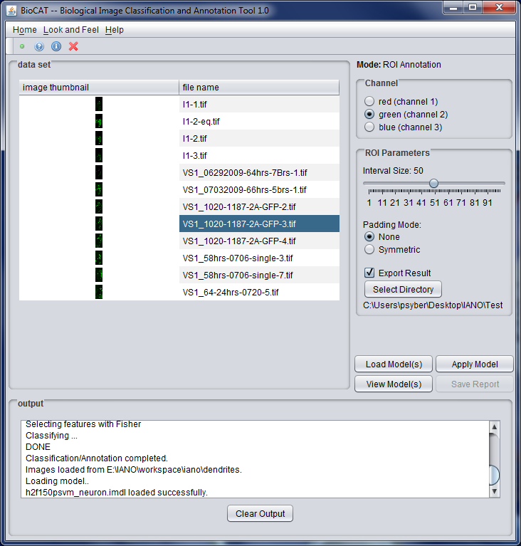

ROI Annotation Screen

## 3D Image Annotation and Classifiation

If you were to load 3D images, in model selection mode, in both “Single” and “Multiple” modes, 3D Feature Extractors (instead of 2D Feature Extractors) can be selected using the drop down lists for model selection. The built model can then be used to classify and annotate the 3D image sets or Regions of Interests.

On the screen with loaded images, you can click on the thumbnail of an image, which will launch the ImageJ 3D viewer so you can view the 3D image (Need to have Java3D installed to launch 3D viewer).

## Reports and Output Files

The reports and files include:

* Model comparison report (pdf)
* Image Classification report (pdf)
* ROI Annotation report (text file)
* Saved model files with extension *imdl* (may contain binary Savable Classifier)
* Saved algorithm chain files with extension *ichn* (editable text file containing algorithm chains)